**Power BI Assignment 3**

1. List and explain different Power BI products?
2. What limitations of Excel, Microsoft solved by Power BI?
3. Explain Power Query?
4. Explain Power Map?
5. How Power BI eliminated the need to host SharePoint Server on premises?
6. Explain the updates done in Power Bi Service (power BI 2.0) as compared to older version?

**Answers**

1.List and explain different Power BI products?

Power BI is a business analytics service provided by Microsoft that lets you visualize your data and share insights. It converts data from different sources to build interactive[dashboards](https://www.simplilearn.com/tutorials/power-bi-tutorial/power-bi-dashboard) and Business Intelligence reports.

Different Power BI Products explained inline:

POWER BI DESKTOP: a Windows desktop application for data analysis and reports creation

POWER BI SERVICE: Online software as a Service, used to collaborate and distribute Power BI reports

POWER BI MOBILE: a native mobile app

POWER BI REPORT BUILDER: a tool for creating paginated reports

POWER BI REPORT SERVER: an on-premises report server (available through Power BI Premium licensing)

1. What limitations of Excel, Microsoft solved by Power BI?

Excel vs Power BI: Data Model

Microsoft Excel is mainly used for simple analysis tasks on historical data only while Power BI deals with the simplification of real-time data obtained from disparate sources, apart from complex analysis of historical data.

### Power BI vs Excel: Language Dependency

Microsoft Excel works with the MDX language for querying the underlying Data Model, while for Power BI, the DAX language is used

### Power BI vs Excel: Collaboration

Power BI lets you share your dashboards and reports with other employees in just a few clicks. This is available for people looking for On-Premise Solutions or In-Cloud Solutions catering to enterprises and small businesses alike.

Microsoft Excel, however, has limited scope for collaboration, integration, and a bunch of other functions and formats. Setting KPIs and organizing complex data structures is simpler in Microsoft Excel due to the presence of a rich set of mathematical formulas to help you along the way.

### Power BI vs Excel: Data Security

Microsoft Excel allows you to restrict access to a file, worksheet, or workbook. You can also lock the files to hide their visibility or give read-only access to prevent editing or modifications. This is all Microsoft Excel has to offer when it comes to Data Security. It does not have a robust, built-in security control, unlike Power BI. Power BI offers a rich assortment of measures to keep your customer data safe like:

* Row-Level Security Feature
* Role-Based Authentication
* Networking Security
* Risk Mitigation
* Session Monitoring
* Cloud-Based Security Provisions

### Power BI vs Excel: Data Visualizations

When it comes to data visualizations, Power BI trumps Microsoft Excel by its sheer ability to analyze a vast amount of data with great ease along with a wide range of charts like Tables, Area Charts, Doughnut Charts, Funnel Charts, etc.

### Power BI vs Excel: Reporting and Dashboarding

Microsoft Excel offers you a limited range of dashboards if you look at interactivity and the range of functions. It has a tabular data format that can help you visualize data with various chart formats. However, it is not an ideal tool for larger datasets. Power BI has a cohort of powerful features like easy formatting, natural language querying, resizing, editing, and filtering that make the reports easy to understand, and visually attractive, while helping you draw multi-faceted insights to guide the decision-making process. Power BI’s reports are highly dynamic and interactive.

1. Explain Power Query?

Power Query is a data transformation and data preparation engine. Power Query comes with a graphical interface for getting data from sources and a Power Query Editor for applying transformations. Because the engine is available in many products and services, the destination where the data will be stored depends on where Power Query was used. Using Power Query, you can perform the extract, transform, and load (ETL) processing of data

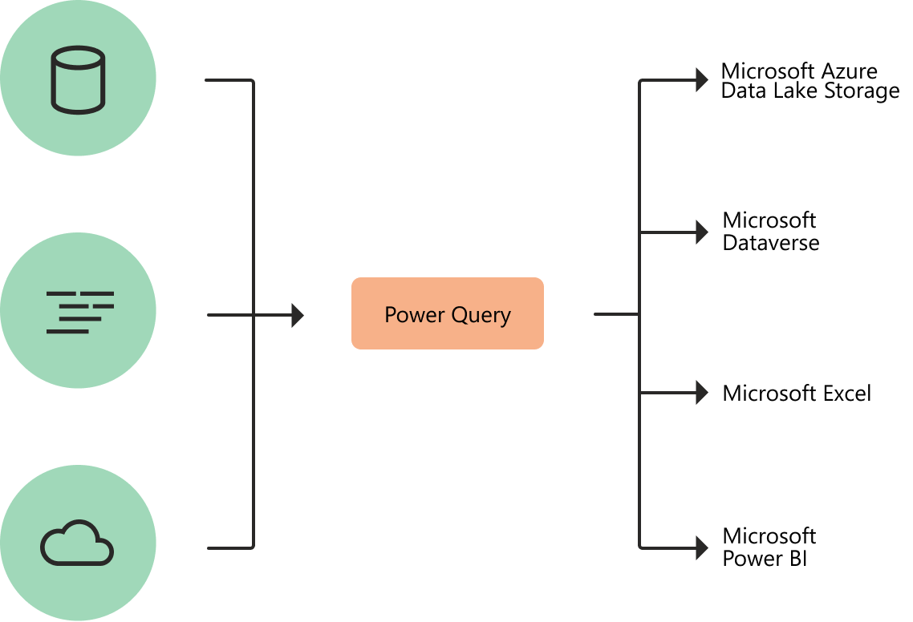

1. Explain Power Map?

Power Map is much more mature in 3D Geo-Spatial visualization, you can have different layers of visualization (such as column chart and heat map, and region visualization). You can zoom into map on particular angle if you want to. You can have a play axis which is very important for story telling.

1. How Power BI eliminated the need to host SharePoint Server on premises?

Power BI is a cloud technology for reporting as however it has also an on-premises solution for which we have Power BI Report Server.

Power BI Reporting server is an instance of reporting services. It’s a whole server hosting environment your setup on premises and you can have Power BI reports in it. so basically it’s a centralized hosting environment which can have your interactive Power BI reports which eliminate the need to host SharePoint server on premises.

6. There are now two different sections in the “Get Data” of your workspace which each of them have two parts:

**Content Pack Library**

* + My Organization: from here you can easily create you organizational content packs. A content pack is basically a single repository to keep datasets, reports, dashboards, Q&A, integration with other data sources, data refresh and more. You can also package up and publish your dashboards, reports and datasets with your colleagues in a specific group or the entire organisation. You can also browse the content packs that other people in your organisation published.
  + Services: you can use lots of online services built to connect to different platforms like Microsoft Dynamics CRM, Microsoft Dynamics Marketing, Visual Studio Online, and much more.

**Import or Connect to Data**

* + Files: You can upload your reports, data or workbooks from Excel, Power BI Desktop or CSV files. The location of the files could be your local hard drive, on OneDrive Business or OneDrive Personal.
  + Databases: You can connect to Azure SQL Database, Azure SQL Data Warehouse, SQL Server Analysis Services Tabular Model or Azure HDInsight (Spark) and browse your live data.

**Reports**

The report’s features are improved significantly. We can know change the chart’s colours, adding free texts into Textboxes and much more.

* After logging into Power BI website clock on a desired report
* Right after you open the report you’ll get prompted to use the new report canvas.
* After you open the report, click on EDIT REPORT
* You might get a message saying “To make changes to this report, you need to convert it to new Power BI report canvas”. You can decide to convert or cancel. As the report that I opened is a test report I’m safe to convert it.
* Now that your report is open click on EDIT REPORT button
* You’ll immediately see a toolbox on the right pane that wasn’t available before
* With the new features we are able to modify the visualisation as desired
* By clicking a chart related features to the chart is added to the visualisation pane
* In this sample I clicked on a bar chart
* In the Fields pane on the right side of the page you can see some queries are highlighted in yellow. These queries are the queries that have some fields participating in the report. You can expand them to find the fields. We can modify the report fields by dragging and dropping the fields into the reporting area OR into the “Fields” section of the Visualisation pane.
* As you can see we can easily change the report type by selecting another report type from the Visualisation pane. In this sample I want to change the report type from Bar Chart to Donut Chart.